AI Usage DISCLOSURE FORM

1. Team Details
Team Name: Deadlock
Project / Product Name: StockMaster Sentinel
Organization / Institution (if any): Ramaiah Institute of Technology
Submission Date: 08-05-2026

2. AI Usage Declaration
Did your team use any Artificial Intelligence (AI) in developing this project? Yes

3. Purpose of AI Usage ( Brief Details)
Idea generation / brainstorming: No
Code generation or assistance: Yes
Used AI assistance for Spring Boot API integration, OpenClaw Skills, and automation scripting
UI / UX design: Yes
Generated dashboard flow ideas and interaction designs
Content creation: Yes
Assisted in documentation, prompts, workflow definitions, and agent persona creation
Data analysis: Yes
AI reasoning used for inventory trend analysis and supplier risk prediction
Testing / debugging: Yes
Used AI to troubleshoot backend integration and automation logic

4. Feature Origin Classification ( Please add/delete based on the number of the feature)

1.Feature Name
Autonomous Inventory Monitoring
2. Self-Generated/AI-Generated/Both:
Both
3. Description
AI Tool/Platform Used: Claude, OpenClaw
Prompt Used: “Create an autonomous inventory agent that proactively monitors stock levels and predicts shortages.”
Output Summary: Generated architecture ideas for periodic inventory checks, low-stock reasoning, and proactive alerts.
Modification: Integrated with custom Spring Boot REST APIs and adapted logic for the StockMaster database system.

1. Feature Name
Supplier Alert & Drafting System

2. Self-Generated/AI-Generated/Both
Both

3. Description
AI Tool/Platform Used: Claude, OpenClaw
Prompt Used: “Draft automated supplier communication messages based on inventory shortages and market conditions.”
Output Summary: Generated discord/telegram templates and automated supplier communication workflows.
Modification: Customized prompts to match warehouse operations and supplier management requirements.

1. Feature Name
Natural Language Business Intelligence Queries

2. Self-Generated/AI-Generated/Both
Both

3. Description
AI Tool/Platform Used: Claude
Prompt Used: “Enable voice/text-based inventory analysis using natural language queries.”
Output Summary: Designed conversational workflows where users can query inventory statistics through Discord or WhatsApp.
Modification: Connected responses to Spring Boot backend APIs and inventory audit logs.

1. Feature Name
Market Intelligence & Supply Chain Risk Detection

2. Self-Generated/AI-Generated/Both
Both

3. Description
AI Tool/Platform Used: ChatGPT, OpenClaw
Prompt Used: “Analyze supplier delays and market price fluctuations using autonomous reasoning.”
Output Summary: Proposed heartbeat-based monitoring logic and contextual reasoning workflows.
Modification: Enhanced with custom inventory thresholds and operational rules.

5. Ethical & Compliance Confirmation
AI usage complies with guidelines and policies. Yes
No proprietary or copyrighted data misused. I Agree

6. Declaration & Sign-Off
Name of Team Representative: Anoushka Paul
Role: Team Leader
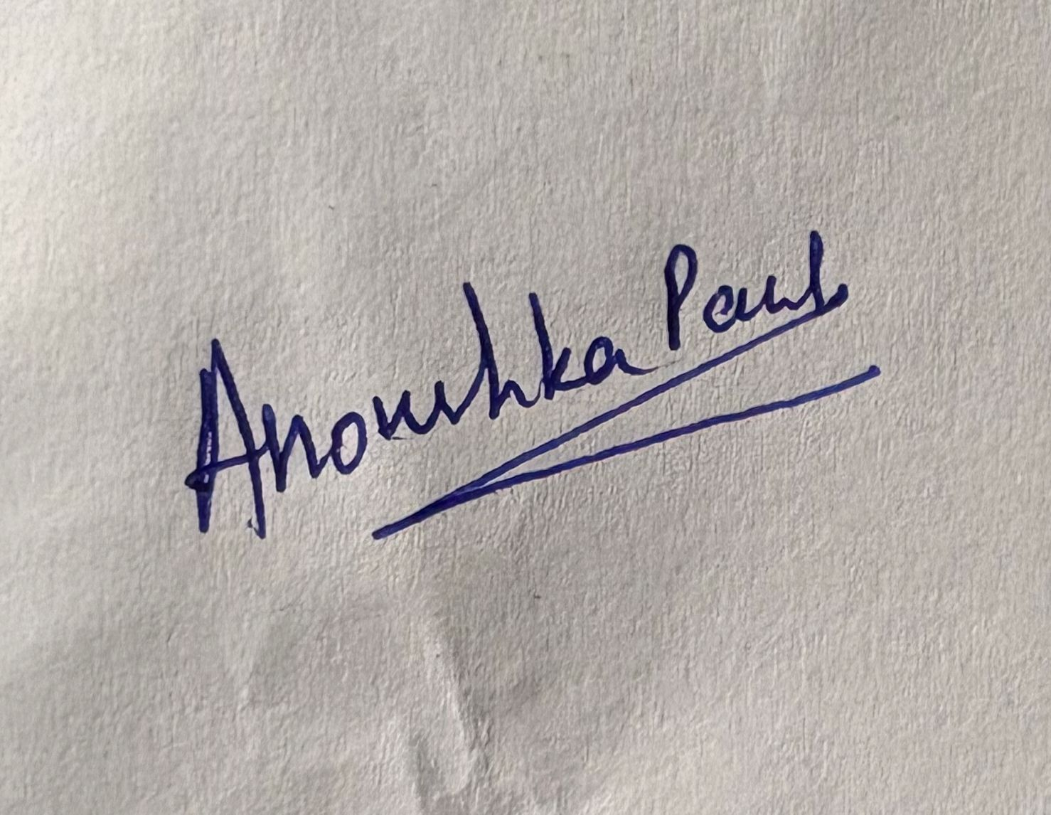
Signature:

Date: 08-05-2026

